Group Emotion Recognition System for Smart Park Monitoring
Parco Nazionale della Sila
Gianluca Perrotta (277091) | Marco Macrì (276608) | Orazio Ruberto (276576) | Asrar Jemal Mohammed (284598)
Academic Year 2025/2026

1. Introduction
Natural parks such as the Parco Nazionale della Sila receive thousands of visitors each year, yet park management lacks objective, real-time tools to assess how visitors emotionally perceive the environment. Understanding the collective emotional state of visitor groups can support crowd management, improve service quality, and contribute to conservation-aware tourism strategies.
Two broad families of approaches exist for automated emotion analysis: sentiment analysis from audio signals, and computer vision from visual data. Audio-based systems infer emotional states from voice tone and prosody, requiring microphone infrastructure and raising significant privacy concerns in public outdoor spaces.
Our system instead adopts a computer vision approach, analysing facial expressions captured from cameras mounted at park locations. The two approaches are complementary: audio captures emotional nuance from speech, while visual analysis is non-intrusive, works in silence, and scales naturally to group settings.
Within the computer vision family, Vision Language Models (VLMs) represent a recent and powerful paradigm. Unlike traditional Convolutional Neural Networks (CNNs), which return a single discrete emotion label with no contextual understanding, a VLM combines a vision encoder with a large language model to jointly process images and text. VLMs natively support tasks such as counting people, describing scenes, and answering open-ended questions about visual content. However, while general-purpose VLMs can handle basic emotion queries, they are not always calibrated for fine-grained facial expression classification or for structured output formats required by IoT pipelines. Fine-tuning is therefore explored to obtain reliable, schema-consistent predictions on the FER+ emotion classes, though its applicability depends on the pre-training characteristics of each model.
The synergy between Internet of Things (IoT) edge devices and Cloud Computing enables a distributed, low-cost system for Group Emotion Recognition (GER). The system deploys Raspberry Pi 5 devices with GoPro cameras as edge nodes across the park, offloading VLM inference to an AWS GPU cloud instance. Each edge node runs a compact face-detection-and-tracking step (OpenCV DNN SSD, ~10 MB, CPU-only) solely to decide when to transmit: a frame is sent every 20 seconds while the same group remains in the scene, and immediately when a new person enters the scene. Three VLMs --- PaliGemma 2, MiniCPM-V, and Moondream2 --- are benchmarked on the FER+ dataset; the best-performing model (Moondream2) is selected for cloud deployment. Results are stored in MySQL on the EC2 instance and visualised through a Flutter mobile dashboard used by park workers. The system provides: (1) real-time GER via a fine-tuned VLM on AWS EC2; (2) lightweight edge processing on Raspberry Pi 5; (3) persistent storage in MySQL; (4) secure access via AWS Cognito and Tailscale VPN; (5) a mobile dashboard with natural-language query support via an AI agent; and (6) a priority queue system to handle concurrent requests from edge nodes and mobile users.

2. Analysis

2.1 Scenario and Constraints
The system is deployed across outdoor locations within the Parco Nazionale della Sila, a protected area in Calabria spanning 73,695 hectares. Key constraints are:
- Connectivity: outdoor areas of the park have limited and intermittent network coverage, thus periodic frame offloading is adopted instead of continuous streaming to limit bandwidth usage.
- Power: edge devices are Raspberry Pi 5 single-board computers without a dedicated GPU, ruling out energy-intensive on-device VLM inference; all deep learning computation is offloaded to the cloud.
- Environment: variable lighting and weather conditions affect image quality and face detection reliability.
- Budget: cloud resources are constrained to $150 total, ruling out managed services such as ALB or DynamoDB at scale.

2.2 Functional Requirements
- FR1 --- Capture video frames from a GoPro camera connected to Raspberry Pi 5 nodes via WiFi live stream.
- FR2 --- Transmit JPEG-encoded frames (~100 KB) to the cloud every 20 seconds while the same group is in the scene, and immediately upon detection of a new person entering the scene.
- FR3 --- Classify dominant group emotion using a fine-tuned VLM (anger, contempt, disgust, fear, happiness, neutral, sadness, surprise).
- FR4 --- Store inference results (emotion label, timestamp, node identifier, people count) persistently on the cloud.
- FR5 --- Provide a mobile dashboard for monitoring per location and time range.
- FR6 --- Support natural-language queries over the stored data via an AI conversational agent.
- FR7 --- Allow mobile users to submit a photo for on-demand emotion classification with higher priority than edge frames.
- FR8 --- Authenticate both mobile users and edge nodes securely.

2.3 Non-Functional Requirements
- NFR1 --- Latency: inference result available within ~3s of frame receipt under normal load.
- NFR2 --- Scalability: backend supports simultaneous requests from multiple edge nodes via a priority queue.
- NFR3 --- Security: all communications encrypted via HTTPS/TLS; private network via Tailscale VPN.
- NFR4 --- Accuracy: selected VLM achieves ≥80% accuracy on FER+ test set after fine-tuning.
- NFR5 --- Interoperability: edge-cloud communication via standard REST APIs over HTTPS.
- NFR6 --- Cost: total cloud spends within $150 budget.

2.4 Analysis Models
These two figures present the SO-centric and IoT Service-centric domain models following the ACOSO-METH notation.

Figure 1 — Object-based ACOSO-METH model
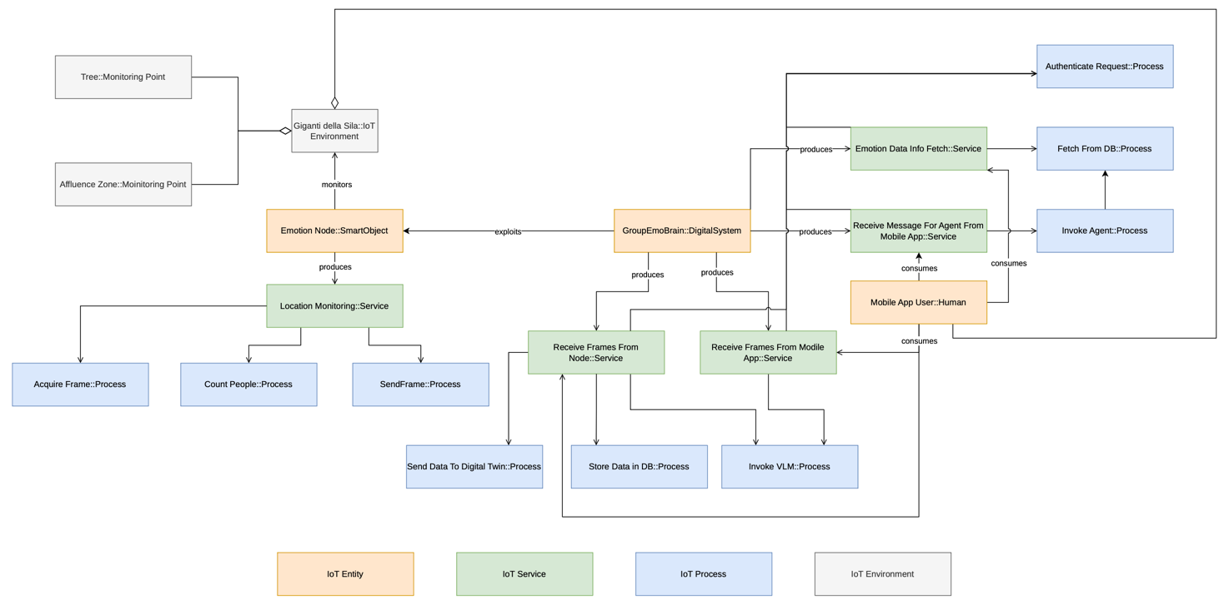
Figure 2 — Service-based ACOSO-METH model
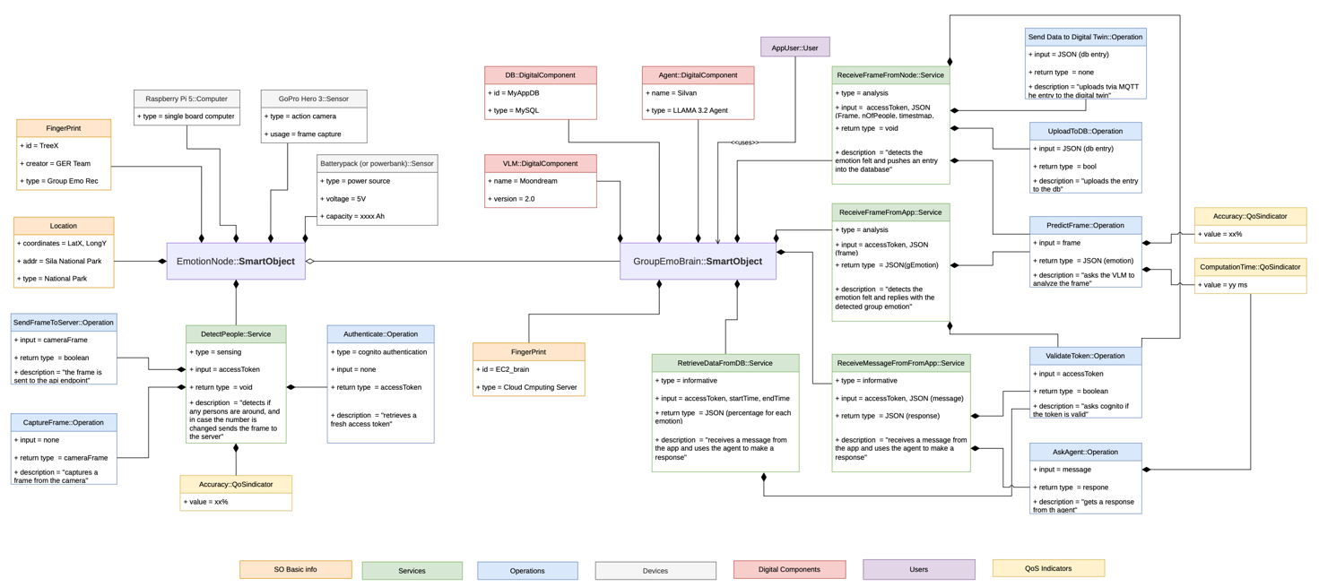

3. Design
Based on the identified requirements, the following design decisions have been taken.
VLM-based inference over CNN (FR3, NFR4): VLMs classify group emotion directly from scene images without requiring face detection or individual labelling, making them more robust to occlusion and group shots.
Cloud offloading over on-device inference (FR2, NFR1): Raspberry Pi 5 devices lack a dedicated GPU; running large VLMs locally would violate the latency requirement. Edge nodes handle only frame extraction and transmission.
Priority queue for VLM access (FR2, FR7, NFR2): a single shared VLM instance serves two request types --- periodic edge frames (normal priority) and on-demand mobile photos (high priority). A weighted priority queue ensures mobile requests are processed first when both queues are busy, preventing starvation while maintaining fairness.
Relational database over NoSQL (FR4, NFR6): emotion records have a fixed schema (node_name, emotion, num_persone, timestamp); MySQL on the same EC2 instance avoids DynamoDB costs while providing full SQL expressiveness for time-range aggregation queries.
Private VPN over managed API Gateway (FR8, NFR3, NFR6): Tailscale VPN connects edge nodes and mobile clients to the EC2 instance in a private mesh network authenticated via AWS Cognito. This eliminates API Gateway and ALB costs (~$24/month) while maintaining security. Aws cognito lets only authorized users access the api. Cognito and tailscale work separately. The tailscale authentication is managed by the tailnet to which we currently access via a google mail account
Text-to-SQL AI agent (FR6): park workers formulate natural-language questions; a local LLM (llama3.2 via Ollama) translates them into safe SQL SELECT queries executed against MySQL, returning answers in natural language.
Token-based authentication (FR8, NFR3): stateless Cognito JWT tokens --- User Pool tokens for mobile users, Client Credentials (M2M) tokens for edge nodes in cognito a user pool contains 2 clients each generating the corresponding tokens (1 for app 1 for nodes)--- are validated by FastAPI without external calls.
Microservice REST backend (FR2, FR5, FR6, FR7, NFR1, NFR5): a single FastAPI service exposes all endpoints, decoupling edge nodes, mobile clients, and internal services (VLM queue, AI agent, MySQL). FastAPI's async runtime handles concurrent requests without blocking, enabling simultaneous edge frame ingestion and mobile queries on the same instance.
Cross-platform mobile application (FR5, FR6, FR7): Flutter provides a single codebase for iOS, windows, linux, mac OS, web and Android with a consistent user experience.
Table 1: Design choices
Requirement | Design Solution
REST backend decoupling all clients (FR2, FR5, FR6, FR7) | Microservice REST API (FastAPI)
Group emotion classification (FR3, NFR4) | VLM-based inference
Limited edge resources (FR2, NFR1) | Cloud offloading to GPU instance
Concurrent edge + mobile requests (FR2, FR7, NFR2) | Priority queue (edge normal, mobile high)
Persistent storage within budget (FR4, NFR6) | MySQL on EC2 (no DynamoDB)
Secure private connectivity (FR8, NFR3, NFR6) | Tailscale VPN + Cognito JWT
Natural-language data queries (FR6) | Text-to-SQL AI agent (Ollama)
Multi-platform dashboard (FR5) | Cross-platform mobile framework (Flutter)
VLM model selection (NFR4) | LoRA fine-tuning + comparative benchmark

4. Implementation
The system combines IoT edge devices, an AWS GPU cloud instance, and a Flutter mobile application in a three-tier device--edge--cloud architecture connected via Tailscale VPN.
Table 2: Implementation choices
Design Solution | Implementation Choice
Edge IoT device | Raspberry Pi 5 + GoPro camera (WiFi live stream)
Frame extraction and transmission | Python + OpenCV; 20s periodic or immediately on new person detected
On-edge perception | OpenCV DNN SSD face detector + position-based tracker (~10 MB, CPU-only)
VLM fine-tuning | QLoRA (FP16) on FER+ via AWS EC2 g4dn.xlarge
Cloud inference service | AWS EC2 g4dn.xlarge (NVIDIA Tesla T4, 16 GB VRAM)
Priority queue VLM service | model_queue_service.py (asyncio, two queues)
REST backend | FastAPI (Python, port 8080)
Relational database | MySQL on EC2 (localhost:3306)
Private connectivity | Tailscale VPN mesh network
Token-based authentication | AWS Cognito (User Pool + M2M Client Credentials)
AI conversational agent | Silvan agent + llama3.2 via Ollama (text-to-SQL)
Cross-platform mobile dashboard | Flutter (Android)
Encryption in transit | HTTPS/TLS on all endpoints (HTTP = no encryption right now)

Raspberry Pi 5 nodes acquire frames from a GoPro camera via its WiFi live stream, received over a dedicated wireless interface and read using OpenCV. Each frame is JPEG-encoded at approximately 100 KB, matching the limited and intermittent connectivity of the park's outdoor locations. A compact on-edge perception step --- an OpenCV DNN SSD face detector (~10 MB, CPU-only) combined with a position-based tracker --- identifies when a new person enters the scene; in that case a frame is transmitted immediately. Otherwise, a frame is sent every 20 seconds on a heartbeat timer. This on-edge step produces no emotion labels and stores no identities; all authoritative counting and emotion classification remain with the cloud VLM. Frames are transmitted via HTTPS POST to the FastAPI backend at POST /emonodes/sendmessage; a successful submission returns HTTP 200 OK.
The backend enqueues the frames in the normal-priority queue of the VLM service; the Moondream2 model classifies the dominant group emotion and the result (emotion label, node name, people count, timestamp) is persisted in MySQL.
The Flutter mobile app, authenticated via Cognito, calls GET /app/data/getbetweendates to retrieve per-node emotion percentages for a selected time range, and POST /app/analyzephoto to classify a user-supplied photo with high priority. The POST /app/askagent endpoint forwards natural-language questions to the Silvan AI agent, which constructs a safe SQL SELECT query, executes it against MySQL, and returns a natural-language answer generated by llama3.2 via Ollama.
The three VLMs --- PaliGemma 2, Moondream2, and MiniCPM-V 4.6 --- were fine-tuned on FER+ (8 emotion classes) using QLoRA on the EC2 g4dn.xlarge instance. Moondream2 is selected for cloud deployment based on its superior accuracy after fine-tuning.

Figure 3 — Deployment diagram: three-tier architecture with Tailscale VPN
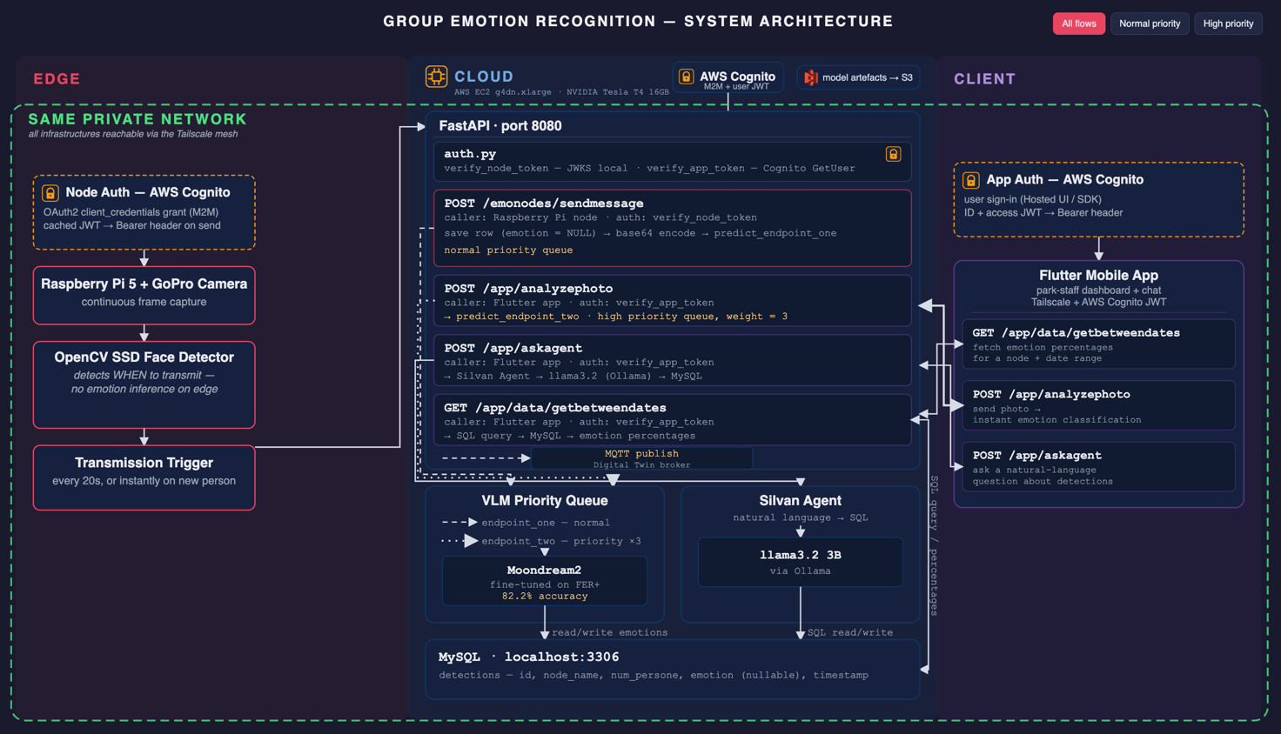

Figure 4 — FastAPI startup sequence
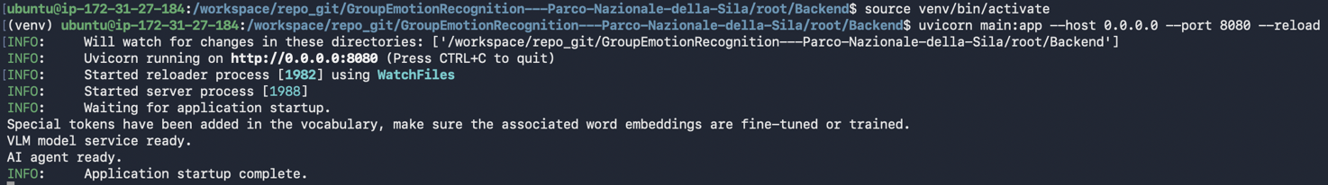

Figure 5 — Whole day emotion statistics dashboard
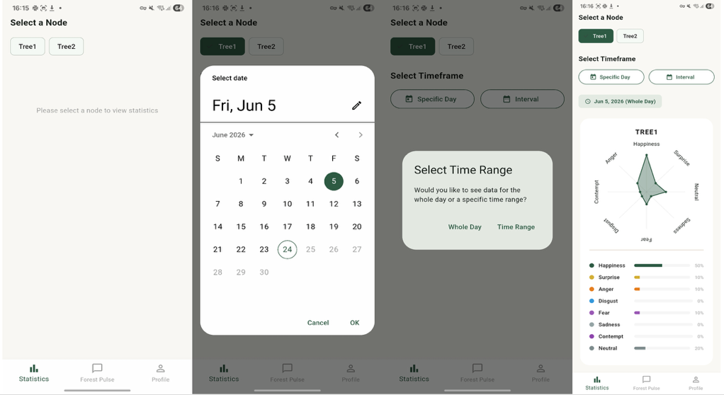

Figure 6 — AI agent chat interface
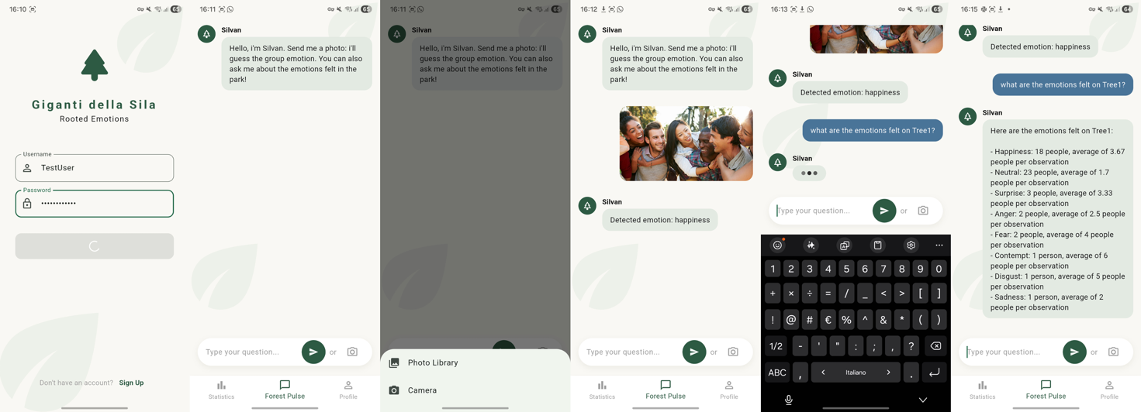
Due to page length constraints, additional figures illustrating the individual API endpoint tests and further mobile application screens are omitted from this section. A comprehensive treatment of each component --- including detailed endpoint flows, test results, and application screenshots --- is provided in the full system report.

4.1 Results
Table 3: PaliGemma 2 evaluation on FER+ test set (3,573 images)
Configuration | Accuracy | Macro F1 | Weighted F1 | Invalid %
Base + JSON prompt (8 classes) | 0.257 | 0.224 | 0.303 | 66.69%
Base + simple prompt (8 classes) | 0.691 | 0.436 | 0.687 | 0.00%
Base + simple prompt (4-class distress) | 0.695 | 0.691 | 0.701 | 0.00%

Table 4: PaliGemma 2 per-class F1 --- base model, simple prompt, 4-class distress schema
Emotion | F1 | Precision | Recall | Support
happiness | 0.880 | 0.899 | 0.861 | 929
neutral | 0.665 | 0.885 | 0.533 | 1274
distress | 0.621 | 0.613 | 0.629 | 920
surprise | 0.598 | 0.438 | 0.944 | 450

Table 5: Moondream2 per-class metrics --- QLoRA fine-tuning, 8-class FER+
Emotion | Precision | Recall | F1 | Support
neutral | 83.68% | 88.15% | 85.86% | 1274
happiness | 92.22% | 91.82% | 92.02% | 929
surprise | 77.80% | 84.89% | 81.19% | 450
sadness | 74.04% | 60.36% | 66.50% | 449
anger | 73.88% | 81.68% | 77.58% | 322
disgust | 25.00% | 33.33% | 28.57% | 21
fear | 59.18% | 29.59% | 39.46% | 98
contempt | 50.00% | 26.67% | 34.78% | 30

Table 6: MiniCPM-V 4.6 per-class metrics --- QLoRA fine-tuning, 8-class FER+
Emotion | Precision | Recall | F1 | Support
neutral | 85.70% | 72.92% | 78.80% | 1274
happiness | 93.54% | 90.42% | 91.95% | 929
surprise | 79.45% | 76.44% | 77.92% | 450
sadness | 56.98% | 57.24% | 57.11% | 449
anger | 69.85% | 70.50% | 70.17% | 322
disgust | 16.67% | 52.38% | 25.29% | 21
fear | 31.18% | 54.08% | 39.55% | 98
contempt | 7.53% | 36.67% | 12.50% | 30

Table 7: VLM benchmark on FER+ test set (8-class)
Model | Strategy | Accuracy |  | Macro F1 | Invalid %
PaliGemma 2 (3B) | Base + simple prompt | 69.1% |  | 0.436 | 0.00%
Moondream2 (2B) | QLoRA fine-tuning (1 epoch) | 82.2% |  | 0.632 | 0.00%
MiniCPM-V 4.6 | QLoRA fine-tuning (1 epoch) | 74.8% |  | 0.567 | 0.00%
Moondream2 achieves 82.2% accuracy after one epoch of QLoRA fine-tuning (1/3 sample fraction, learning rate 1e-5, vision encoder frozen) on FER+, with 0% invalid predictions. Per-class highlights: happiness 92.0% F1, neutral 85.9%, surprise 81.2%, anger 77.6%; minority classes (disgust 28.6%, fear 39.5%, contempt 34.8%) remain weak due to class imbalance in FER+.
MiniCPM-V 4.6 achieves 74.8% accuracy after one epoch of QLoRA fine-tuning (FP32 adapter) on FER+, with 0% invalid predictions. Per-class highlights: happiness 92.0% F1, neutral 78.8%, surprise 77.9%, anger 70.2%; minority classes (disgust 25.3%, fear 39.6%, contempt 12.5%) remain weak for the same class-imbalance reasons.
For PaliGemma 2, fine-tuning with LoRA at multiple learning rates consistently produced rapid overfitting due to the model's strong prior knowledge of facial expressions from SigLIP pre-training. The base model with a simple direct prompt achieves 69.1% accuracy and Macro F1 of 0.436 on the 8-class schema, and 69.5% accuracy with Macro F1 of 0.691 on the 4-class distress schema. Moondream2 is selected for cloud deployment based on its superior accuracy and 0% invalid prediction rate across all tested configurations.
The end-to-end latency --- frame capture to MySQL write --- is estimated at 1.5--3.2s under normal conditions (frame encoding: ~0.1s; transmission via Tailscale: ~0.3--0.8s; VLM inference on T4: ~1.0--2.2s; DB write: ~0.05s), satisfying NFR1. AI agent first-response latency (llama3.2, Ollama) is ~40s cold, ~20s warm.

5. EdgeCloudSim Simulation
EdgeCloudSim provides a simulation environment specific to Edge Computing scenarios, modelling both computational and networking resources. It was used to validate the offloading pipeline with 1--10 concurrent Raspberry Pi nodes over a 10-hour simulation window, without requiring physical hardware.
Five custom components were implemented:
- PeriodicFrameLoadGenerator --- generates one frame-analysis task per camera every ~20 s with random jitter.
- ParkNetworkModel --- handles camera-to-edge upload delay and edge-to-cloud-storage result transfer delay.
- VlmEdgeOnlyOrchestrator --- routes every task to the edge VM where the VLM is deployed.
- FixedCameraMobilityModel --- assigns each camera a fixed location read from edge_devices.xml.
- ParkCameraScenarioFactory --- connects all components and drives the simulation.

5.1 Experimental Results
The number of camera devices is varied from 1 to 10. Each camera periodically generates frame-analysis tasks offloaded to the edge node representing the VLM execution environment.
Table 8: Simulation results for 1--10 cameras over 10 hours
Cameras | Tasks | Completed | Failed | Serv. Time (s) | Net. Delay (s) |  | Edge Util. (%)
1 | 1791 | 1791 | 0 | 2.147762 | 0.147762 |  | 7.612688
2 | 3584 | 3584 | 0 | 2.147859 | 0.147860 |  | 16.026711
3 | 5382 | 5382 | 0 | 2.147965 | 0.147963 |  | 22.971619
4 | 7190 | 7190 | 0 | 2.148078 | 0.148065 |  | 31.786311
5 | 8983 | 8983 | 0 | 2.148219 | 0.148185 |  | 39.666110
6 | 10773 | 10773 | 0 | 2.148859 | 0.148357 |  | 45.409015
7 | 12569 | 12569 | 0 | 2.149169 | 0.148462 |  | 53.422371
8 | 14365 | 14365 | 0 | 2.149866 | 0.148542 |  | 61.569282
9 | 16170 | 16170 | 0 | 2.150915 | 0.148638 |  | 70.651085
10 | 17963 | 17963 | 0 | 2.153954 | 0.148712 |  | 78.931553
Task generation. The expected number of frames per camera over 10 hours is 10 × 3600 / 20 = 1800. With 10 cameras the observed average interval is 36000 / (17963/10) ≈ 20.04 s, confirming the workload generator behaves consistently with the intended 20-second transmission period.
Reliability. The failure rate is 0% across all configurations. No task fails due to VM capacity, mobility, WLAN range, or network failure, indicating that the edge-only VLM architecture is stable under the tested workload range.
Latency. The average service time remains stable at ~2.15 s as cameras grow from 1 to 10:
T_service = T_processing + T_network ≈ 2.00 s + 0.15 s
This aligns with the measured end-to-end latency of 1.5--3.2 s on the real system, satisfying NFR1. Edge utilisation reaches 78.9% at 10 nodes, confirming the EC2 g4dn.xlarge instance sustains the expected park workload without saturation. As expected, given the absence of mobility and the full offloading to the edge, the system remains stable under the assumption that no network links to the edge fail.

6. Conclusion
The proposed GER system addresses all defined requirements through a distributed IoT--cloud architecture. Frame acquisition (FR1, FR2), VLM-based emotion classification (FR3), persistent MySQL storage (FR4), mobile dashboard (FR5), natural-language AI agent (FR6), on-demand photo analysis with priority queue (FR7), and secure authentication via Cognito and Tailscale VPN (FR8, NFR3) are fully implemented. For PaliGemma 2, fine-tuning with LoRA at multiple learning rates consistently produced rapid overfitting due to the model's strong prior knowledge of facial expressions from SigLIP pre-training. The base model with a simple direct prompt achieved 69.5% accuracy and Macro F1 of 0.691 on the 4-class distress schema, satisfying NFR5. Moondream2 achieves 82.2% accuracy on FER+, satisfying NFR4. The priority queue ensures mobile requests are served promptly alongside continuous edge node streams, satisfying NFR2.
Future developments include short video clip analysis for improved temporal consistency, motion-triggered capture to reduce unnecessary transmissions, anomaly alert notifications in the mobile app, a production-grade deployment with API Gateway and ALB replacing Tailscale, and domain-specific fine-tuning on images collected directly within the park to improve performance on real-world outdoor group scenarios.
Contributions
Orazio Mattia Ruberto 276576
VLM Fine-Tuning Schema and Code — Designed and implemented the general fine-tuning pipeline for the Vision-Language Models. This included applying QLoRA with 4-bit NF4 quantization, managing the chat conversion prompt to enforce structured JSON outputs, and implementing stratified sampling to preserve the original class distribution. I also integrated loss masking to isolate the assistant's answers and set up training guardrails, such as early stopping and learning-rate reduction to handle loss explosions.
This was done primarily for MiniCPM-V and served as the starting point for every model.
VLM Evaluations — Designed and implemented the evaluation pipeline for the Vision-Language Models. I then analyzed global classification performance and per-class behavior, and generated confusion matrices to identify specific model weaknesses, such as the frequent misclassification between disgust and contempt. This detailed evaluation ultimately drove the decision to select Moondream 2 as the final deployed model.
VLM Metrics Choice — Defined the specific evaluation metrics for the benchmarking process, which included accuracy, balanced accuracy, macro F1, and per-class F1. I specifically utilized the Macro F1 score to account for the severe class imbalance in the FER+ dataset, ensuring that the model's performance on underrepresented minority classes was accurately measured.
The Agent (Silvan) — Developed SILA, the Llama 3.2 based AI agent, to seamlessly translate natural language user queries into secure, parameterized SQL. I implemented its robust, deterministic three-stage pipeline: a strict JSON query planning stage, deterministic regex fallbacks to bypass LLM errors, and the final SQL-to-natural language synthesis phase that forces the model to rely exclusively on fetched database rows to prevent hallucinations.
EdgeCloudSim — Set up and executed the EdgeCloudSim environment to simulate and validate the system's architecture without requiring physical implementation. I configured the custom simulation components, including the PeriodicFrameLoadGenerator, ParkNetworkModel, and VlmEdgeOnlyOrchestrator. I also analyzed the final experimental results across a 10-hour simulation, verifying zero task failures and confirming a stable average service time of approximately 2.15 seconds for edge-only VLM execution.

Gianluca Perrotta 277091
FastAPI Backend — Co-designed with Marco the four REST endpoints and solely implemented the entire backend on the EC2 g4dn.xlarge instance using FastAPI with full async/await support: POST /emonodes/sendmessage (frame ingestion, two-phase DB write, normal-priority VLM queue), GET /app/data/getbetweendates (per-node emotion percentage aggregation), POST /app/analyzephoto (high-priority VLM queue), POST /app/askagent (natural-language query forwarding to Silvan agent).
VLM Integration — Integrated Marco's fine-tuned Moondream2 and model_queue_service.py into the FastAPI startup lifecycle. The model is loaded onto the GPU once at startup; endpoint_one (normal priority) serves Raspberry Pi frames, endpoint_two (weight=3) serves app photo requests, ensuring mobile responsiveness under continuous edge load.
AI Agent Integration — Integrated Orazio's Silvan agent as a direct Python import. Because handle_request is synchronous and blocking, it is offloaded via asyncio.to_thread to keep the event loop free. A warmup call at startup pre-loads llama3.2 into Ollama, eliminating the ~50s cold-start penalty on the first user query.
MQTT Digital Twin Integration — Integrated Marco's MQTTService.py publisher into the backend. Broker host, port, and topic are configured at startup from .env via publisher.set_info(), so the ngrok address can be updated without code changes. After each VLM classification, the detection is forwarded to the digital twin broker in Eclipse Ditto format inside a try/except block — MQTT failures never affect the 200 OK returned to the Raspberry Pi.
Tailscale VPN Infrastructure — Configured the private Tailscale mesh network (realized by Marco) connecting Raspberry Pi nodes and the Flutter app to the EC2 backend, replacing AWS API Gateway (~$24/month) to stay within the $150 budget.
AWS Infrastructure — Configured and managed the EC2 g4dn.xlarge instance, MySQL on the same host (zero extra cost), the detections table schema, AWS Cognito User Pool and M2M Client Credentials (these last two realized by Marco) for the two authentication flows, and instance auto-shutdown policy to minimize idle costs.
System Testing — End-to-end tested all four endpoints with real data on the live EC2 instance using valid Cognito tokens, verifying response correctness against MySQL for all tested queries. JPG, PNG, and JPEG formats confirmed working.
PaliGemma 2 VLM — Fine-tuning experiments at multiple learning rates (all resulting in overfitting due to SigLIP pre-training). Base model evaluation: 69.1% accuracy, 0.436 Macro F1 on FER+ 8-class; 69.5% accuracy, 0.691 Macro F1 on 4-class distress schema. 0% invalid predictions across all runs.

Marco Macrì 276608
API Endpoints — Collaborated with Gianluca to design and validate critical communication endpoints. Successfully established a seamless, secure data flow across the entire network mesh.
AWS Infrastructure — Architected and deployed a secure cloud infrastructure backbone.
- Implemented AWS Cognito for centralized user authentication and given everyone the corresponding code/requests to require and validate JWTtokens.
- Carried out the design of scalable data models using Amazon DynamoDB (interrupted mid process. Not used due to cost and ease of testing).
- Proposed a design for a custom API Gateway integration to isolate internal computing instances from public exposure, as done in production lines. This was even interrupted due to costs.
Secure Network Topology (Tailscale VPN) — Engineered a cost-effective, rapid-deployment network security strategy by implementing a private Tailscale VPN (Tailnet). This bypassed high-cost traditional networking infrastructure while completely isolating the core EC2 instance from public internet threats. The alternative was Amazon’s API Gateway.
End-to-End System Testing — Validated overall system integrity and deployment stability of my single implementad parts and then tested the synergy of said parts in the complex system.
New small group emotion dataset for visual human validation — Curated, formatted, and processed a specialized group emotion recognition dataset (taken from stock photos and movie frames) to rigorously test and baseline all VLMs performance.
Vision-Language Model (VLM) Optimization — Went though the successful fine-tuning of the Moondream 2 VLM, successfully adapting the model to extract and classify targeted emotional indicators. Actually made multiple runs tweaking some parameters but some of the ries ended out triggering and suddenly sopping due to validation parameters being not so steady. Ended up choosing the best run (also the one that took less time to carry out).
Asynchronous Service Architecture (VLM-as-a-Service) — Engineered a dual-queue priority architecture to manage VLM inference requests. Implemented strict rate-prioritization logic that prioritizes real-time user mobile app interactions over automated background EmotionNode data collection to guarantee the app user shorter waiting periods.
IoT Messaging & Edge Integration — Developed a Python-based backend messaging microservice using the MQTT protocol. This ensures that the same data that we get from the Emotion Nodes are immediately forwarded to the digital twin’s broker on the specified topic. The strength is the fast integration with the backend. In fact everything is reduced to 1 (max 2: one for changing defaults) function call in the backend
Full-Stack Mobile Application — Designed, built, and deployed the cross-platform flutter based mobile application.
- Integrated secure authentication lifecycles (Sign-Up/Login/Logout via Cognito),
- Built custom hooks for real-time relational data retrieval via the core MySQL backend
- Integrated the conversational AI interface layer.
- Managed the connection to the tailnet
Hardware Provisioning & Edge OS Configuration — Established the foundational edge-computing setup for the team. Provisioned the base Raspberry Pi OS image, automated headless SSH and VNC configurations, and engineered scriptable automatic access point connections for rapid deployment. I lent Asrar the already configured micro SD card and adapter.
ACOSO Methodology Analysis & Modeling — Led the analytical part in order to produce the offered ACOSO methodology diagrams in order to give higher level gist of what the system can do and how it is done.

Asrar Jemal Mohammed 284598
Edge Node Application — Designed and implemented the Python application running on the Emotion Node (Raspberry Pi 5) that captures frames from the GoPro camera, performs on-device face detection and tracking to decide when to transmit, and sends each frame to the cloud. This is the device-to-cloud edge software of the system.
Device Configuration and Hardware Setup — Configured the real hardware end to end: connected the GoPro to the Raspberry Pi over a dedicated USB WiFi adapter (wlan1), set up and tested the GoPro live-stream capture, and purchased and installed the microSD card required for the GoPro to stream.
Tailscale Connectivity (Edge Side) — Joined the Raspberry Pi to the project's Tailscale tailnet and verified secure connectivity from the edge device to the EC2 instance, so the node could reach the cloud over the private network (tailnet proposed and set up by Marco).
Cloud Authentication (Edge Side) — Implemented the Cognito machine-to-machine (M2M) token flow on the Pi: requesting, caching, and auto-refreshing the access token and attaching it as a Bearer credential on every request, aligned with the secure-access backbone provided by Marco.
End-to-End System Testing — Integration-tested the full device-to-cloud path together with Gianluca Perrotta, sending live frames from the Raspberry Pi over Tailscale to the EC2 endpoint and confirming successful transmission.
Documentation — Authored the edge-tier technical report and the edge README, documenting the hardware, the connection architecture.

